

Department of Software Technology

De La Salle University - Manila

Term 2, A.Y. 2023 - 2024

Network Applications Protocol

(NSCOM01)

Major Course Output 1

MCO1

Group 6 - S13

Members:

Ha, Eun Ji

Mata, Maria Sarah Althea A.

Submitted to

Dr. Marnel Peradilla

**Message Formats**

**Read Request (RRQ)**

| Opcode = 1 | Filename | 0 | Mode=”octet” | 0 |
| --- | --- | --- | --- | --- |
| 2 bytes | String | 1 byte | String | 1 byte |

**Write Request (WRQ)**

| Opcode = 2 | Filename | 0 | Mode=”octet” | 0 |
| --- | --- | --- | --- | --- |
| 2 bytes | String | 1 byte | String | 1 byte |

**Data (DATA)**

| Opcode = 3 | Block # | Data (variable length up to 512 bytes) |
| --- | --- | --- |
| 2 bytes | 2 bytes | 0 to 512 bytes |

**Acknowledgment (ACK)**

| Opcode = 4 | Block # |
| --- | --- |
| 2 bytes | 2 bytes |

**Error (ERROR)**

| Opcode = 5 | Error Code | 0 | ErrorMessage | 0 |
| --- | --- | --- | --- | --- |
| 2 bytes | 2 bytes | 1 byte | String | 1 byte |

**Sequence Diagrams**

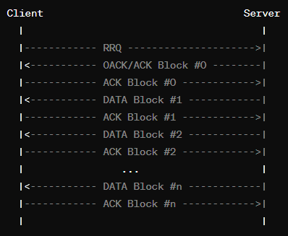

*Figure 1*. Write Request (WRQ) Sequence Diagram

*Figure 1* presents the TFTP protocol's write operation. The client sends a WRQ to the server, indicating the file to be written. The server acknowledges this with an ACK for block 0, prompting the client to send the file in blocks. Each block sent by the client is acknowledged by the server before the next is sent. The process concludes when the server acknowledges the final data block, indicating the file has been successfully written.

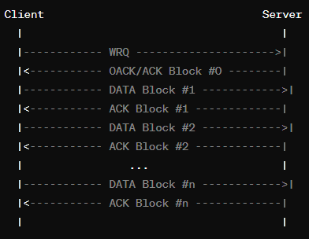

*Figure 2*. Read Request (RRQ) Sequence Diagram

*Figure 2* depicts the TFTP protocol's read operation. It starts with the client sending an RRQ to the server for a file. The server responds with the first data block, which the client acknowledges. This exchange of data and acknowledgments continues until the server sends a final, potentially smaller data block. The client's acknowledgment of this block completes the file transfer.